ANNUAL REPORT 2023-24 9.02.2024
- Session-2023-24
- School Name- ADARSH HITKARINI CHILDREN ACADEMY GOVINDGANJ.
- Established Year -2008
- website address-https://hggs.hitkarini.edu.in Telephone Number-0761-4923833
5. About School :-
The renowned & oldest educational organization of Jabalpur city – Hitkarini Sabha established in 1868 AD has been providing education to students of rural and urban areas to create sincere and better citizens. To accomplish this goal, Hitkarini Sabha set up schools in various residential areas of the city, as per requirement.
Following this sequence, a middle school under the name of Hitkarini Govindganj was established in the Milloniganj area on 16th August 1948. Later it was upgraded upto Higher Secondary level. Currently the school is running successfully under the name ‘Hitkarini Higher Secondary School, Govindganj’. It is spread over a large campus offering large play grounds and an environment conducive for learning. The school building have been upgraded and renovated, however, the original architecture and look has been maintained. The original building was built by the family of Raja Gokuldas, and his son Dewas Bahadur Jeewandas and nephew Deewan Bahadur Vallabhdas, as is evident from the ceremonial stone on the building. Late Pandit Durga Prasad Awasthi was the first principal of the school.
Hitkarini School, Govindganj has been progressing ahead along with the other academic institutions of Hitkarini Sabha. Its alumni are well placed in various fields including politics, social service, teaching, journalism, etc. Keeping with the societal needs of the time, an English medium school, Hitkarini Children Academy, Govindganj has been established with modern curriculum including an updated computer education curriculum. Under the successful Management of Mrs. Jyotsana Dixit the school upgrading every year .It is a self financed school.
Member of School Management Committee
1 | Chairman / Vice Chairman | President
2 | Secretary / Joint Secretary | Member
3 | Chairman / Secretary | Member,Hitkarini Vidya Parishad
4 | Mr. Jayesh Singh Rathore | Member
5 | Mr. Jai Singh Rao Gaikwad | Member
6 | Mr. Anant Badreiya | Member
7 | Mr. Devendra Singh Rajput | Member
8 | Mr. Sanjay Baghel | Member
9 | Mr. Naman Agrawal | Member
10 | Mr. Mukesh Shrivastava | Member ,Sankul Principal,  Govt. Boys Hr. Sec. School, Govindganj
11 | Mrs.Jyotsana Dixit | Principal Higher / HCA Govindganj

FEATURES OF SCHOOL
- We have trained, experienced B.Ed. teachers.
- Affordable fees structure.
- Special remedial classes for students in Board Examination so that the results would be good.
- Many playing equipments in kids zone.
- The school has a large play ground for the students.
- Garden is very well maintained with various seasonal plants & flowers.
- There is laboratory facility available in the school with two labs:
a) Computer Lab
b) Science Lab
- We have got affiliation for Higher Secondary School.

Student strength details of last three years:
CLASS | 2023-24 | 2022-23 | 2021-22
NURSERY | 28 | 24 | 6
LKG | 33 | 31 | 10
UKG | 31 | 32 | 23
I | 35 | 43 | 20
II | 44 | 31 | 23
III | 35 | 37 | 21
IV | 34 | 35 | 23
V | 42 | 36 | 26
VI | 40 | 42 | 36
VII | 48 | 39 | 32
VIII | 48 | 45 | 28
IX | 71 | 59 | 50
X | 58 | 49 | 41
XI(SCI) | 32 | 14 | NIL
XI(COM.) | 35 | 24 | NIL
XII(SCI.) | 13 | NIL | NIL
XII(COM.) | 23 | 15 | NIL
TOTAL | 650 | 556 | 339

Student Annual Result Details of last three years:
CLASS | 2022-23 | 2021-22 | 2020-21
NURSERY | 100% | 100% | 100%
LKG | 100% | 100% | 100%
UKG | 100% | 100% | 100%
I | 100% | 100% | 100%
II | 100% | 100% | 100%
III | 100% | 100% | 100%
IV | 100% | 100% | 100%
V | 100% | 100% | 100%
VI | 100% | 100% | 100%
VII | 100% | 100% | 100%
VIII | 97.7% | 100% | 100%
IX | 89.83% | 100% | 100%
X | 89.79% | 88% | 100%
XI(SCI) | 100% | NIL | NIL
XI(COM.) | 95% | NIL | NIL
XII(SCI.) | NIL | NIL | NIL
XII(COM.) | 100% | NIL | NIL

Student Teacher Ratio in School – 650:22=29:1
Average Workload of Teachers- 30-36 Periods
Total Teaching days : 172
School Timing: 7:55 AM -- 2:00 PM.
Details of Teachers and staff working in the school – 3 years
S.NO. | Employee | 2023-24 | 2022-23 | 2021-22
1 | Principal | 1 | 1 | 1
2 | Teacher | 23 | 17 | 10
3 | Peon | 4 | 3 | 3
4 | Guard | 2 | 1 | -
Total |  | 30 | 22 | 14

Academic Activities:-
1.Welcome of students-On 10th April 2023 we welcome our students with tilak and pooja organized .Our teachers also presented gifts to our new admission of toddlers.And also organized some games to entertain them.
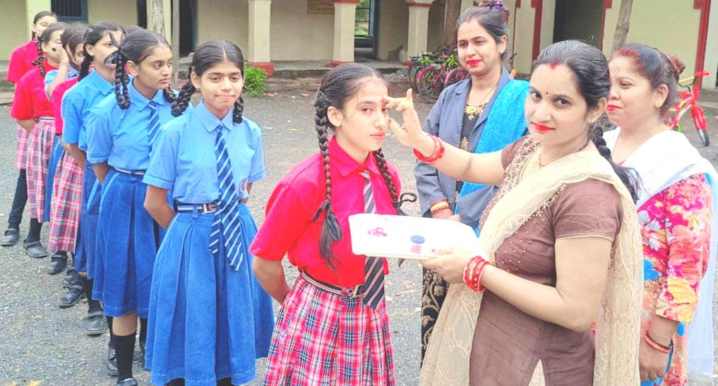
2.International Yoga day – On 21st June 2023 yoga day was celebrated with great enthusiasm by teachers and students both.
3. Interaction with parents- on 15th July 2023 a parents teacher meeting is held with all the class teachers with parents and teachers giving information for whole years.
4. Green day –ON 22nd July2023 was celebrated as Green day and Plantation day here we planted small plants with the help of children and explain them about the importance of trees.
5.Independence day- 15th August2023 was celebrated as Independence day .Our Chief guest Shri Jayesh Rathore(Secretary Hitkarini VIdya Parishad ) hosted flag .Our special guest Mrs.Varsha Jaiswal (MIS Co-Ordinator of BRC Office Nagar -1) given speech on this national day.
6 .Drawing Competition – on 19th August 2023 a Drawing competition organized by Gunjan Kala Sadan For different schools in Jabalpur Here children express their feelings with the help of colors which is very beautiful.
7.Rainy Day - On 26th August 2023 rainy day was celebrated with the hope of dream and beautiful colors of our life. Children enjoyed a lot with their umbrella and Raincoat.
8. Rakhi & Mehandi competition – On 28th august 2023 was celebrated as Rakhi(Primary level) and Mehandi(school level).
9. National Sports Day- On 29th August 2023 was celebrated with full enthusiasm. Children learned about the importance of sports in our life.
10.Teachers Day – On 5th September 2023 teacher day was celebrated by old students of Hitkarni H.S.School Govindganj and current students with their beautiful cultural activities.
11. Shri Krishana Janashmatami – On 6th September 2023 the festival of wisdom and spirit enthusiasm of love and friendship was celebrated by toddlers who dressed as Radha and Krishna with Matki Phode competition organized .

12.Quarterly Examination- On 15th September 2023 quarterly examination was started
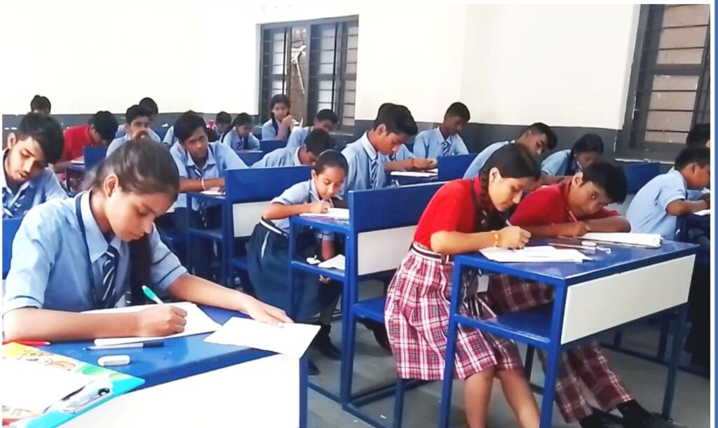
13.Remidial board classes - On 1st October classes were organized for class 5th , 8th ,10th and 12th .
14.Swacch Bharat Abhiyan & Gandhi Jayanti Celebration –On 2nd October Swacch Bharat Abhiyan was conducted by NCC students and Gandhi ji vesh bhusha competition and chart making competiton on Swacch Bharat .
Swacch Bharat Abhiyan
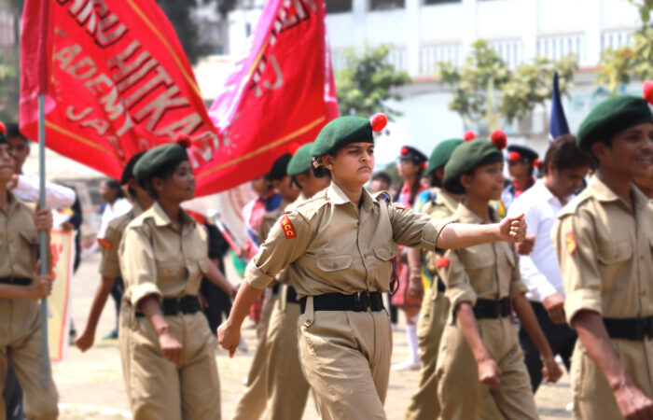

Gandhi JI Vesh Bhusha Competition
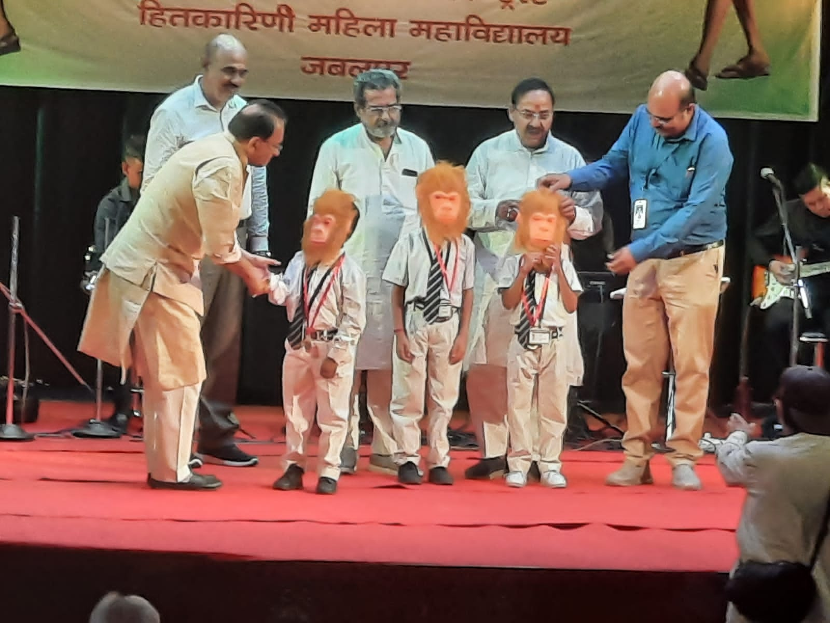

15. Science & Computer Exhibition - On 4th October 2023 Interhitkarini Science and computer exhibition was organized by Hitkarini Vidya parishad. Our children scored positions in all categories.
Category | Class | Rank | Student name
Computer (Non-Working) | VIII | First | 1.Anshika Jain  2.Ojasiwini Raikwar
Computer(Working) | IX & X | First | 1.Khushal Thakur  2.Sahiba Namdeo
Science (Working) Higher Secondary | XI &XII | First | 1.Aditi dey  2.Anuradha Parihar
Science (Non-working) Higher Secondary | IX & X | First |  | 1.Shreya Agarwal  2. Sonam Viswakarma
Science (Non -working)  Middle level | VII&VI | Third prize |  | 1.Chirag Chadar  2. Shreya gupta
Science (Working) | VII | Second Prize |  | 1.Vaishnavi Rajak  2. Adesh Yadav

Science & Computer Exhibition
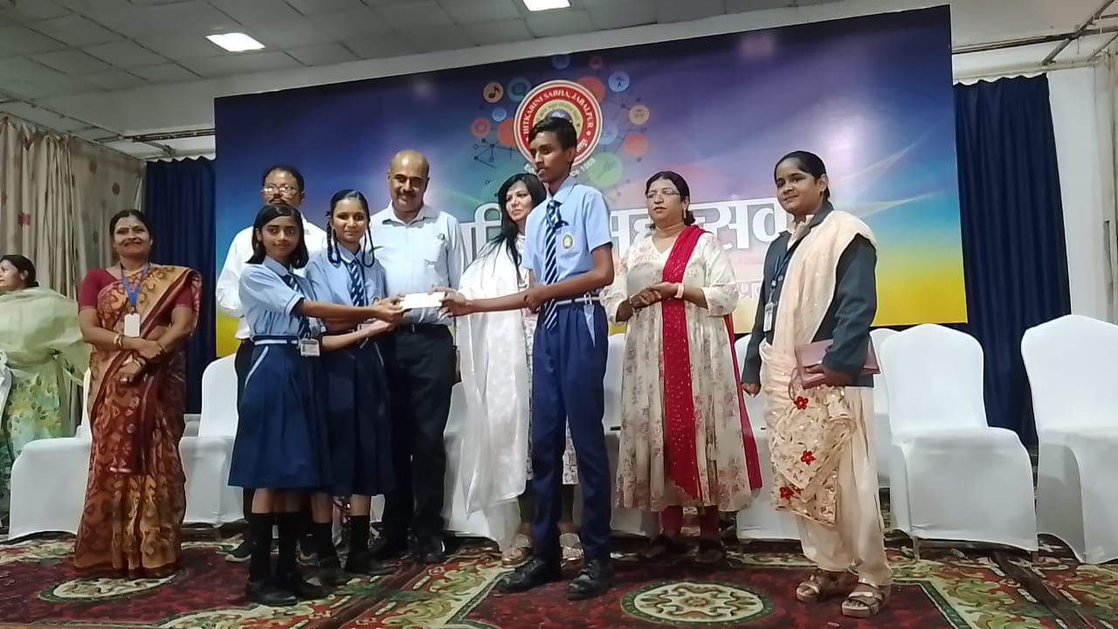

CULTURAL AND SPORTS ACTIVITIES
1. Sports - 67th state level school tournament archery competition in which Aashi Koshta won the gold medal .
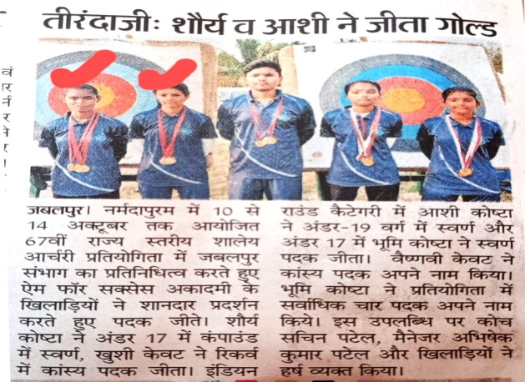
2. Cultural Activity – On 13th October2023 Rotry club organized national group song competition . In which students of our school won gold medal
3. Hitkarini Mahotsav – In Hitkarini mahotsav HCA Govindganj done very well
Sports Section
- Drshit saraf from class 12th got first prize in 100 m and 200 m race
- Darshit saraf and Yuvraj Singh got first and second prize in Shot Put .

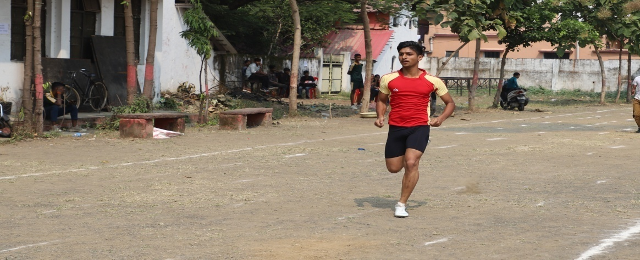

Cultural Section
a.We got first prize in all categories (Solo Song, National Anthem, Group Song) in Song Competition
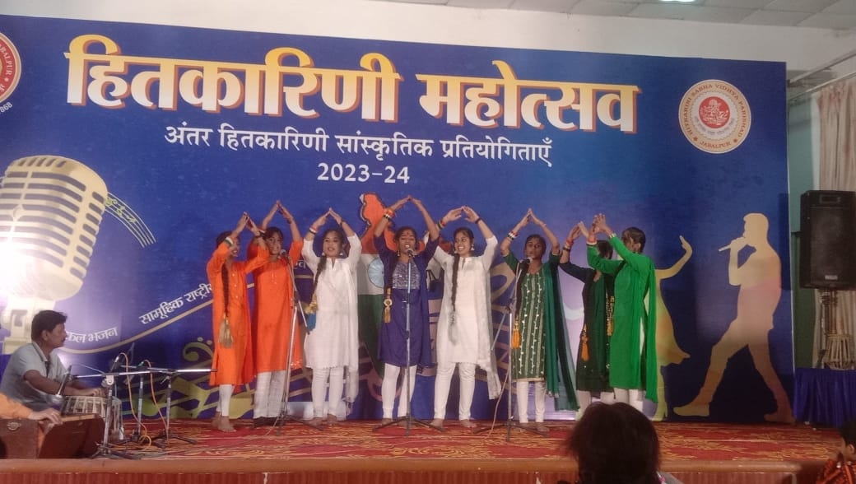

b.Third prize in Solo Dance
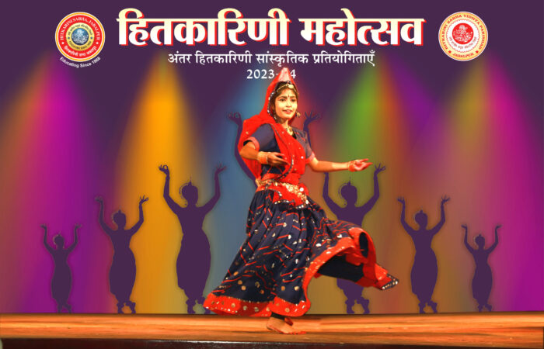
c. Third prize in Group Dance
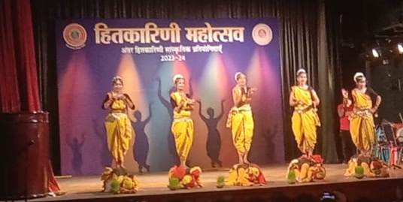
Training Program and Workshop - On 26th December to 30th December English training program was organized by Hitkarini Sabha for teachers to learn English language properly .
- Priyanka Tiwari
- Rashmi Chakarwarty
- Shaheen Mansoori
- Trupti Makode
- Rekha Naidu
Parents Teachers Meeting –
a.On 30th October 2023 PTM of Quarterly Examination successfully held in our school.
b. ON 6th January 2023 PTM of Half Yearly Examination successfully held in our school.
c. ON 29th January PTM of Pre-Board Examination was also successfully done.
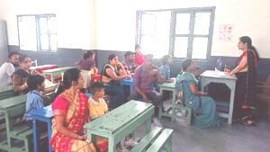
NCC Activities - NCC camp was organized from 13th October to 21st October at Pragya Dham Ashram Katangi by 1 MP sig Coy NCC Jabalpur .

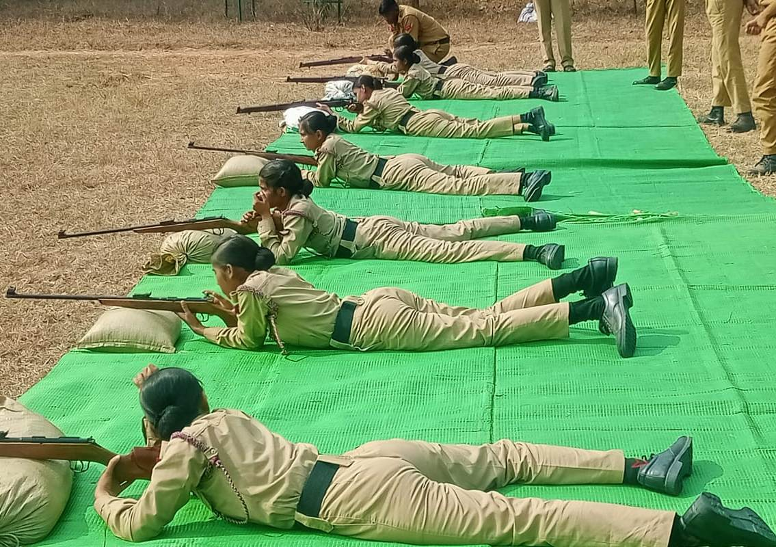

Board class results –Our Twinkling stars of 2022-23 Class-12th
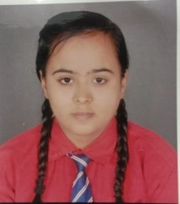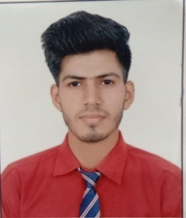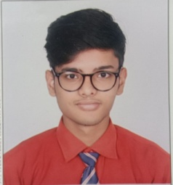
Diksha Gupta Gautam Pahuja Anuj Soni
85% 83% 79%
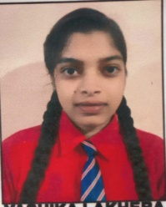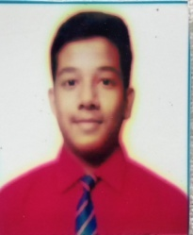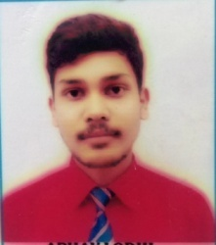
Yashika Lakhera Sidhhant Koshta Abhay Lodhi
81% 79% 73%
Class 10th
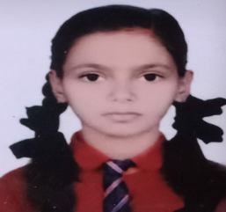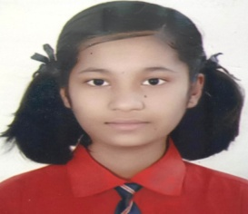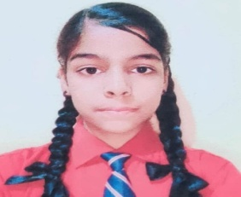
Devanshi Koshta Dolly Koshta Anshika Chourasiya
90 % 87% 86%

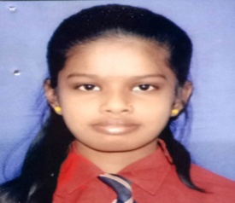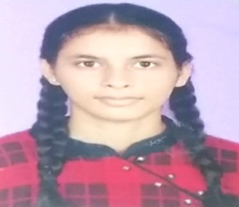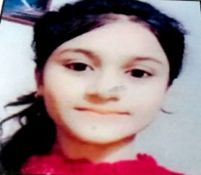
Muskan Vishwakrma Aashi Koshta Jiya Koshta
84% 84% 83%

No of books in Library – 150

Other Major Achievements-
1.Our previous year 8 students of class 12th scored above more than 75% and they got 25000/- from former chief minister Mr. Shivraj Singh Chouhan.
2.Among all Hitkarini children academy only our school got 85% result in class 10th .
3.Class 12th student Darsit saraf national level athlete.
4 Bhumi Koshta and Aashi Koshta achieved gold medal in state level championship in Archery.
5 Vasu Agrahari got gold medal in Yoga at district level.
6. Vishwajeet Koshta ,Lakshya Koshta , Arushi samundre and Namrta Kacchi selected in judo karate at District level.
Proposed Plans-
- To strive for emphasizing on quality admission.
- In the upcoming session 2024-25, our target is to admit quality wise admissions. Admission will be given only after taking written test and interview capability of students.
- Parents should be well educated and their financial condition should be very good.
- We are trying to give best education to our students.
- Six rooms are required for next session.
Details of Alummni
S.No | Name | year | Address | Name of Institution | Post
1 | Shri Krishna Kant Koshta | 1963 | Chota Fuhara | BSNL | Director
2. | Shri Adarsh Muni Trivedi | 1964 | Gopal Baag | High Court | Advocate
3. | Dr. B.L.Rusiya | 1965 | Sarswati Colony | Sr. Doctor | Doctor
4. | Shri Satyendra Vishwakarma | 1973 | Badhiyaa Mohalla | DRDO | Director
5. | Shri Satyam Diwedi | 2016 | Gohalpur | Army | Officer

Scholarship Detail :-
Name of the institution |  | Number of PBF students of the institution |  |  | Financial Assistance to poor/meritorious students from other social,religious and other institutions
 |  | No. | Amount |  | No. | Amount
Hitkarini Higher Secondary School |  | 19 | 85070 |  | Gopal Lal ji Trust  Agrawal Samaj  Shri Rangnath Trust (20) | 15500/-  12000/-  20000/-
Adarsh Hitkarini Children Academy Govindganj |  | 39 | 68995 |  | Gopal Lal ji Trust  Agrawal Samaj  Shri Rangnath Trust (20)
Total |  | 58 | 154065 |  |  | 47500/-

Gratitude & Regards :- Our entire staff of HCA Govindganj would like to convey our heartfelt regards to Sabha for providing us each facility & salary on time.
Principal Name: Mrs. Jyotsana Dixit
Designation: Principal
Qualification: M.A. B.ED.
Mobile No.: 8319141520,9752712757
Mail Id : dixit111jyotsana@gmail.com

