ANNUAL REPORT 2024-25
- Session-2024-25
- School Name- ADARSH HITKARINI CHILDREN ACADEMY GOVINDGANJ.
- Established Year -2008
- website address-https://hggs.hitkarini.edu.in Telephone Number-0761-4923833
5. About School :-
The renowned & oldest educational organization of Jabalpur city – Hitkarini Sabha established in 1868 AD has been providing education to students of rural and urban areas to create sincere and better citizens. To accomplish this goal, Hitkarini Sabha set up schools in various residential areas of the city, as per requirement.
Following this sequence, a middle school under the name of Hitkarini Govindganj was established in the Milloniganj area on 16th August 1948. Later it was upgraded upto Higher Secondary level. Currently the school is running successfully under the name ‘Hitkarini Higher Secondary School, Govindganj’. It is spread over a large campus offering large play grounds and an environment conducive for learning. The school building have been upgraded and renovated, however, the original architecture and look has been maintained. The original building was built by the family of Raja Gokuldas, and his son Dewas Bahadur Jeewandas and nephew Deewan Bahadur Vallabhdas, as is evident from the ceremonial stone on the building. Late Pandit Durga Prasad Awasthi was the first principal of the school.
Hitkarini School, Govindganj has been progressing ahead along with the other academic institutions of Hitkarini Sabha. Its alumni are well placed in various fields including politics, social service, teaching, journalism, etc. Keeping with the societal needs of the time, an English medium school, Hitkarini Children Academy, Govindganj has been established with modern curriculum including an updated computer education curriculum. Under the successful Management of Mrs. Jyotsana Dixit the school upgrading every year .It is a self financed school.
Member of School Management Committee
1 | Chairman / Vice Chairman | President Hitkarini Sabha
2 | Secretary / Joint Secretary | Member
3 | Mr. Jayesh Singh Rathore | Chairman/ Secretary
4 | Mr. Jai Singh Rao Gaikwad | Member
5 | Mr. Anant Badreiya | Member
6 | Mr. Devendra Singh Rajput | Member
7 | Mr. Sanjay Baghel | Member
8 | Mr. Naman Agrawal | Member
9 | Mr. Deepak Rathore | Member
10 | Mr. Mukesh Shrivastava | Member ,Sankul Principal,  Govt. Hr. Sec. School, Govindganj
12. | Mrs.Jyotsana Dixit | Principal Higher / HCA Govindganj

FEATURES OF SCHOOL
- We have trained, experienced B.Ed. teachers.
- Affordable fees structure.
- Special remedial classes for students in Board Examination so that the results would be good.
- Many playing equipments in kids zone.
- The school has a large play ground for the students.
- Garden is very well maintained with various seasonal plants & flowers.
- There is laboratory facility available in the school with two labs:
a) Computer Lab
b) Science Lab
- We have got affiliation for Higher Secondary School.

Student strength details of last three years:
CLASS | 2024-25 | 2023-24 | 2022-23
NURSERY | 12 | 28 | 24
LKG | 37 | 33 | 31
UKG | 32 | 31 | 32
I | 31 | 35 | 43
II | 37 | 44 | 31
III | 43 | 35 | 37
IV | 42 | 34 | 35
V | 36 | 42 | 36
VI | 44 | 40 | 42
VII | 45 | 48 | 39
VIII | 49 | 48 | 45
IX | 69 | 71 | 59
X | 69 | 58 | 49
XI(SCI) | 15 | 32 | 14
XI(COM.) | 40 | 35 | 24
XII(SCI.) | 32 | 13 | NIL
XII(COM.) | 34 | 23 | 15
TOTAL | 667 | 650 | 556

Note:-1. XI Science : 9 students in Maths and 6 students in Biology.
2. XI Commerce : 9 students in Economics and 31 students in IP .
3. XII Science : 19 students in Maths and 13 students in Biology.
4. XII Commerce : All 34 students are in IP

Student Annual Result Details of last three years:
CLASS | 2023-24 | 2022-23 | 2021-22
NURSERY | 100% | 100% | 100%
LKG | 100% | 100% | 100%
UKG | 100% | 100% | 100%
I | 100% | 100% | 100%
II | 100% | 100% | 100%
III | 100% | 100% | 100%
IV | 100% | 100% | 100%
V | 97% | 100% | 100%
VI | 100% | 100% | 100%
VII | 100% | 100% | 100%
VIII | 98% | 97.7% | 100%
IX | 100% | 89.83% | 100%
X | 96% | 89.79% | 88%
XI(SCI) | 100% | 100% | NIL
XI(COM.) | 100% | 95% | NIL
XII(SCI.) | 100% | NIL | NIL
XII(COM.) | 100% | 100% | NIL
Student Teacher Ratio in School – 650:22=29:1
Average Workload of Teachers- 30-36 Periods
Total Teaching days : 179
School Timing: 7:55 AM – 1:30 PM.
Details of Teachers and staff working in the school – 3 years
S.NO. | Employee | 2024-25 | 2023-24 | 2022-23
1 | Principal | 1 | 1 | 1
2 | Teacher | 25 | 24 | 17
3 | Peon | 4 | 4 | 3
4 | Guard | 1 | 2 | 1
Total |  | 31 | 31 | 22

Academic Activities:-
1.Welcome of students-On 10th April 2024 we welcome our students with tilak and pooja organized .Our teachers also presented gifts to our new admission of toddlers.And also organized some games to entertain them.
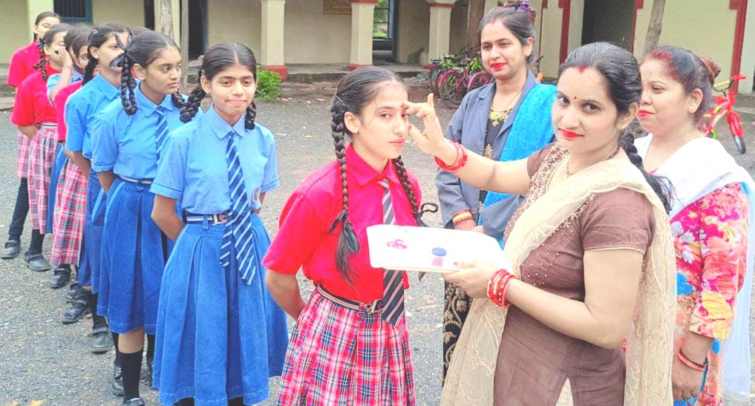
2.International Yoga day – On 21st June 2024 yoga day was celebrated with great enthusiasm by teachers and students both.
3. Interaction with parents- on 6th July 2024 a parents teacher meeting is held with all the class teachers with parents and teachers giving information for whole years.
4. Green day –ON 25th July 2024 was celebrated as Green day and Plantation day here we planted small plants with the help of children and explain them about the importance of trees.
6.Debate competition – Hum foundation oraganized a debate competition on social media ka badhata upyog samajik avm parivarik vyvasta ke liye In this competition HCA Govindganj scored second rank our class10th children sonam Vishwakarma and Om Vishawakarma participated and secured second position.
5.Independence day- 15th August2024 was celebrated as Independence day .Our Chief guest Shri Nityaniranjan Khamparia(Chairman Hitkarini Sabha) hosted Flag and our special guest Mr.Arvind Jain (member Hitkarini vidya parishad) give speech on this national day. Plantation is also done by Chairman sir
6 .Drawing Competition – on 17th August 2024 a Drawing competition organized by Gunjan Kala Sadan For different schools in Jabalpur Here children express their feelings with the help of colors which is very beautiful.
7.Rainy Day - On 26th August 2024 rainy day was celebrated with the hope of dream and beautiful colors of our life. Children enjoyed a lot with their umbrella and Raincoat.
8. Rakhi & Mehandi competition – On 17th august 2024 was celebrated as Rakhi(Primary level) and Mehandi(school level).
9.. Shri Krishana Janashmatami – On 24th August 2024 the festival of wisdom and spirit enthusiasm of love and friendship was celebrated by toddlers who dressed as Radha and Krishna with Matki Phode competition organized
10. National sports Day – on that day Hitkarini Sabha Got the shield for extraordinary sport activity in National Level
11.Teachers Day – On 5th September 2024 teacher day was celebrated by old students of Hitkarni H.S.School Govindganj and current students with their beautiful cultural activities. .
12.Quarterly Examination- On 15th October 2024 quarterly examination was started
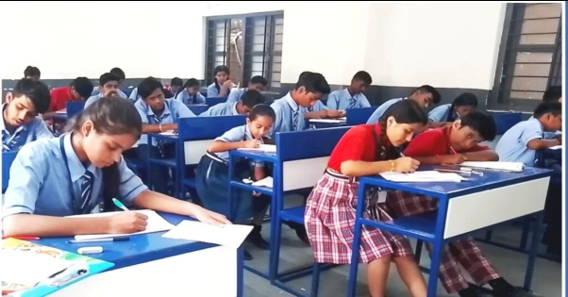
13.Remidial board classes - On 1st October classes were organized for class 5th , 8th ,10th and 12th .
14.Swacch Bharat Abhiyan & Gandhi Jayanti Celebration –On 2nd October Swacch Bharat Abhiyan was conducted by NCC students and Gandhi ji vesh bhusha competition and chart making competiton on Swacch Bharat .
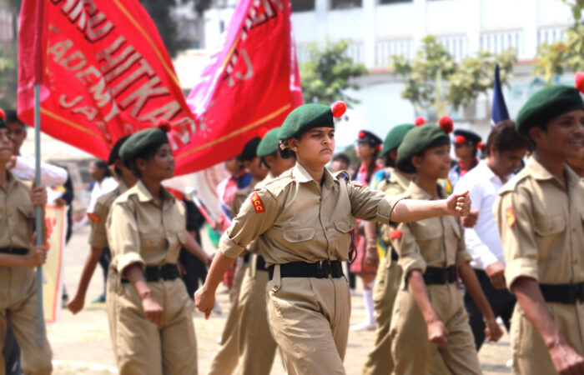
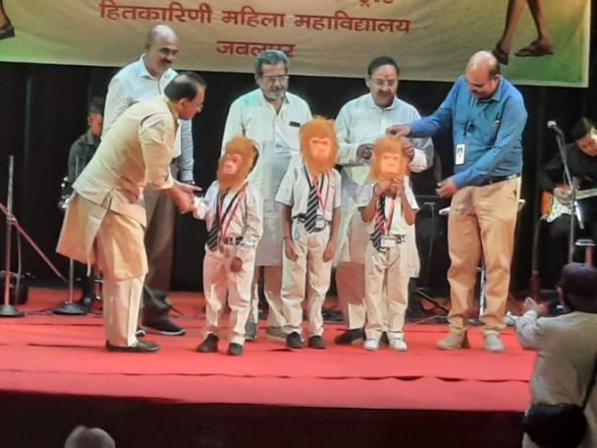
15. Science & Computer Exhibition - On 4th October 2023 Interhitkarini Science and computer exhibition was organized by Hitkarini Vidya parishad. Our children scored positions in all categories.
S.NO. | CLASS | PROJECT NAME | PROJECT TYPE | STUDENT NAME | RANK
1 | CASS 12TH COMMERCE | COMPUTER WEBSITE | WORKING | MUSKAN VISHWAKARMA | I
 |  |  |  | MUSKAN PARIHAR,Jaipal | I
2 | CLASS 10TH | FETAL DEVELOPMENT | NON WORKING | SONAM VISHWAKARMA | II
 |  |  |  | ANJANI VISHWAKARMA | II
3 | CLASS 9TH | ARDUINO WHEEL CHAIR | WORKING | Kanan Koshta, Parth Shukla | I
 |  |  |  | OM VISHWAKARMA | I
4 | CLASS 8TH | APPLICATION OF AI USING ROBOT | WORKING | CHIRAG CHADAR | II
 |  |  |  | ANANYA KORI,AYUSH RATHOR | II

CULTURAL AND SPORTS ACTIVITIES
. Hitkarini Mahotsav – In Hitkarini mahotsav HCA Govindganj done very well
Cultural and Sports Section
a. We got first and second prize in poem competition.
b. We got second prize in Book Talk Show .
c. Third prize in Group Dance .
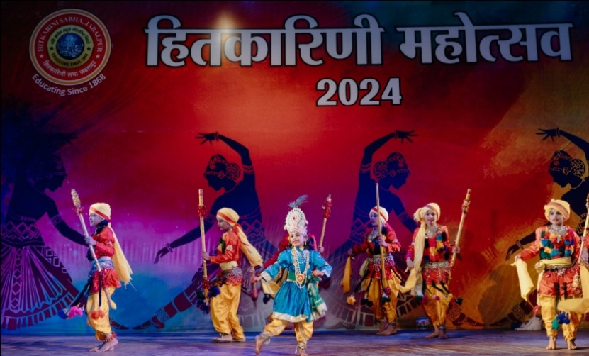
d. We got third prize in talk show.
e. We got first prize in Badminton.
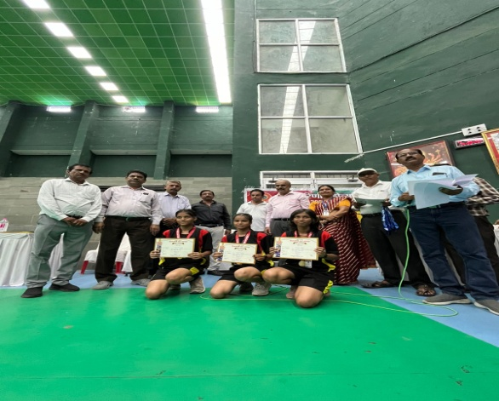
f. Runner up in Volleyball in girls and boys team.
g. Winner in Kabbdi boys team.
h. We got first and second prize in shot-put .
i. We got second prize in discuss throw and Javelin throw.
j. We got first and second prize in 100 meter race .
k. We got first prize in song competiton( solo song ,national , folk ).
l. We got first Prize in solo dance competition for both categories Primary as well as school level.
m. We got third prize in group dance competition in primary level

Drawing competition was organized by Nagar Nigam on 26th October in Bhawartal Garden in which our 5 children got cash prizes worth 5500/-
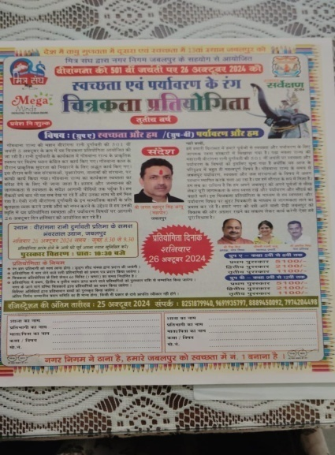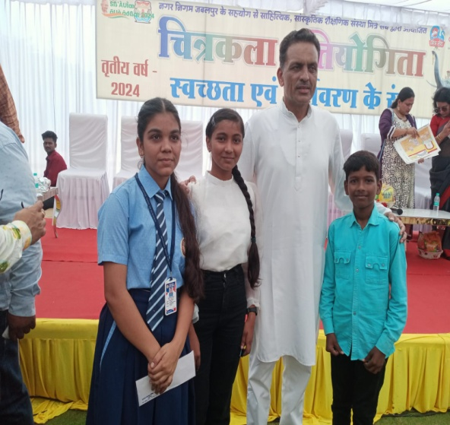
Akhil Bharitya Vidya Parishad was organized Kabbadi competiton in which our children secured third prize.
Parents Teachers Meeting –
a.On 9/11/2024 PTM of Quarterly Examination successfully held in our school . All over 87% Parents attend the meeting.
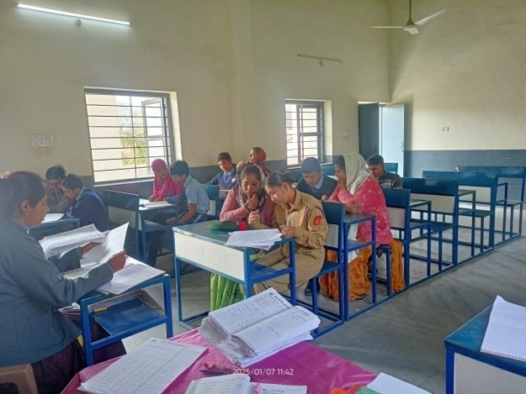
b. ON 7 /1/2025 PTM of Half Yearly Examination successfully held in our school. All over 92% Parents attend the Meeting.
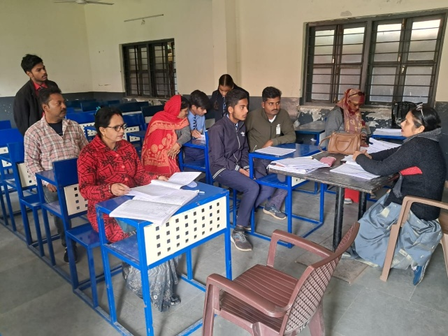
Training Program and Workshop - English training program was organized by Hitkarini Sabha for teachers to learn English language properly
Cyber Security Training was successfully attended by teachers on 30/08/2024 at Law College.
Computer Training Session – Computer Training was successfully attended by teachers on 16/12/2024 to 27/12/2024 at law college.

NCC Activities - 1. NCC camp was organized by unit in Rajasthan in which 5 girls from our school attended and scored medals in Rifle shooting.
2. Second camp was organized for all cadets by Old Nehra company Dumna .
Educational tour was for class 12th students in Hitkarini engineering college.
No of books in Library – 150
We have received RTE fees amount of session 2022-23 rs.1,76,758/-.
Other Major Achievements-
1.Our previous year 11 students of class 12th scored above more than 75% .
2.Among all Hitkarini children academy only our school got 84.7% result in class 10th ..
4 Bhumi Koshta and Aashi Koshta achieved gold medal in state level championship in Archery.
5. Class 7th students Namrata Kacchi got gold medal in judo Karate .
6. Vishwajeet Koshta ,Lakshya Koshta , Arushi samundre and Namrta Kacchi selected in judo karate at District level
Proposed Plans-
- To strive for emphasizing on quality admission.
- In the upcoming session 2025-26, our target is to admit quality wise admissions. Admission will be given only after taking written test and interview capability of students .
- Parents should be well educated and their financial condition should be very good.
- We are trying to give best education to our students.
- Six rooms are required for next session.
- One Auditorium and sports academy.
Scholarship Detail :-
Name of the institution |  | Number of PBF students of the institution |  | Financial Assistance to poor/meritorious students from other social,religious and other institutions
 |  | No. | Amount | No. | Amount
Adarsh Hitkarini Children Academy Govindganj |  |  |  | Gopal Lal ji Trust  Agrawal Samaj | 28643/-  4500/-
Total |  |  |  |  | 33143/-
Shri Rangnath Trust distributed 3-3 sets of books for class 9th to 12th
students.
Gratitude & Regards :- Our entire staff of HCA Govindganj would like to convey our heartfelt regards to Sabha for providing us each facility & salary on time.
Principal Name: Mrs. Jyotsana Dixit
Designation: Principal
Qualification: M.A. B.ED.
Mobile No.: 8319141520,9752712757
Mail Id : dixit111jyotsana@gmail.com

